# Project Name: Handling User Authentication.

## Output:

### Landing Page:

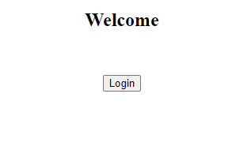

### Dashboard Page (Entering data for login):

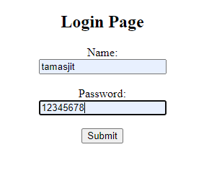

### For Wrong Login:

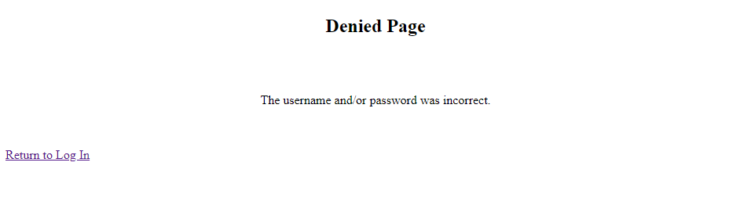

### For Successful Log in:

